Setting the Microsoft Account
- Click the Start button and then choose Settings. In the Settings window, choose Accounts (shown in Figure 7.10).
- 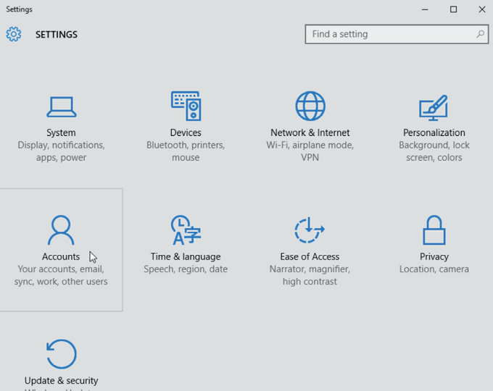
- In the Accounts window, click the “Sign in with a Microsoft account instead” link (shown in Figure 7.11).
- 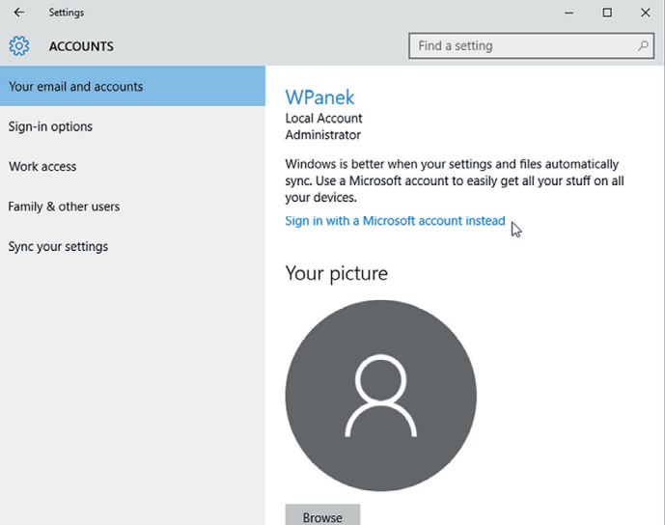
- A new window will appear that states “Make it your.” Type in your Microsoft online username and password. Then click the Sign In button.
- If a box pops up asking for your Windows network password, enter it and click Next.
- If you don’t have a password, just click Next.
- The screen will ask you to enter a PIN. Click the Set A PIN button (shown in Figure 7.12) and set your PIN.
- 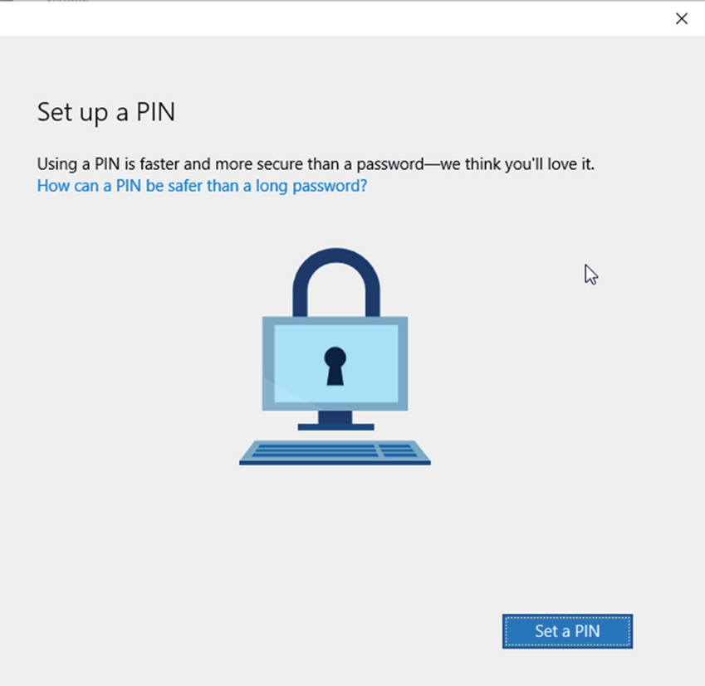
- After the PIN is completed, you are all set. Close the Accounts window.

